Step1:

We Initially create a Amazon webservice account .

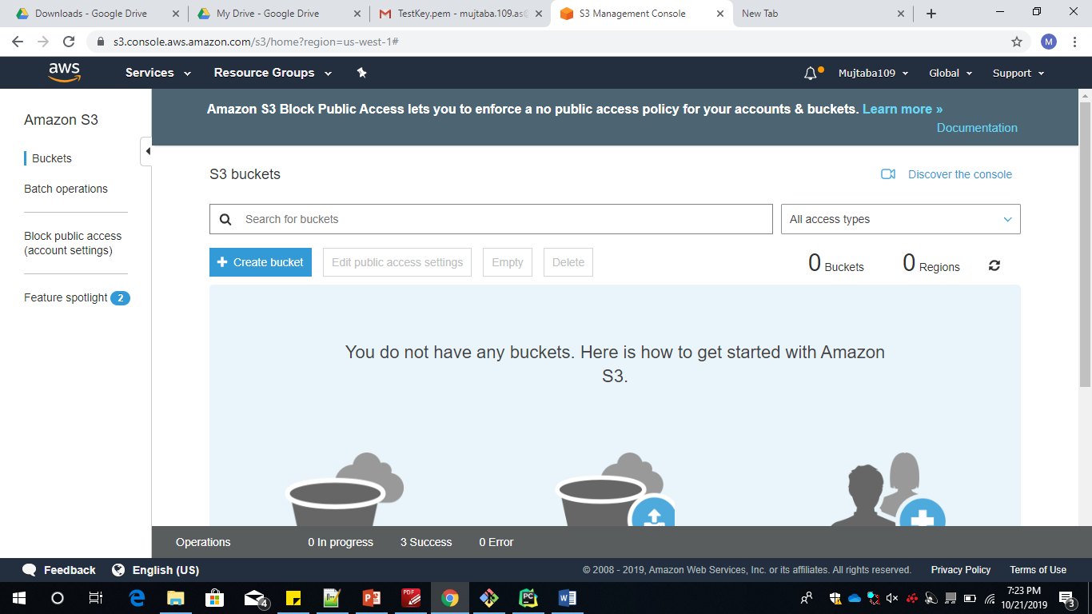

To implement machine learning algorithms which provide an input based on a particular dataset we need to store a file on storage in Cloud.Amazon webservice provides us with S3 buckets on which we store the dataset that is in the form of .json file.

The Creation of s3 bucket can be done from the Services menu .where we can get multiple option .among them select s3 bucket.

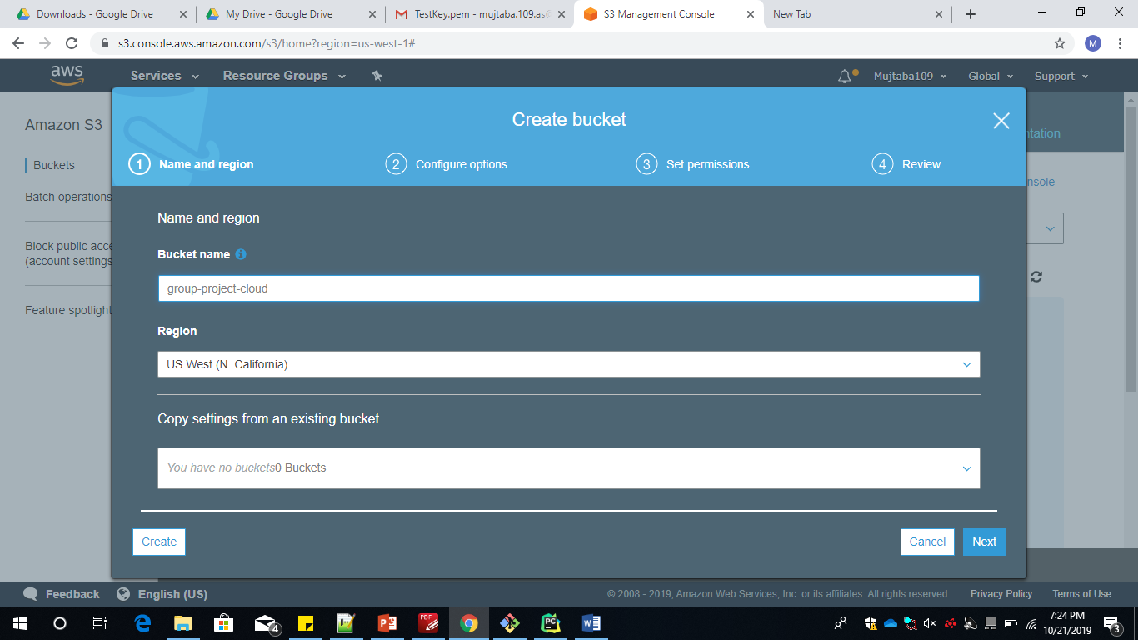

We give change permission for the bucket which makes it available to any public access .

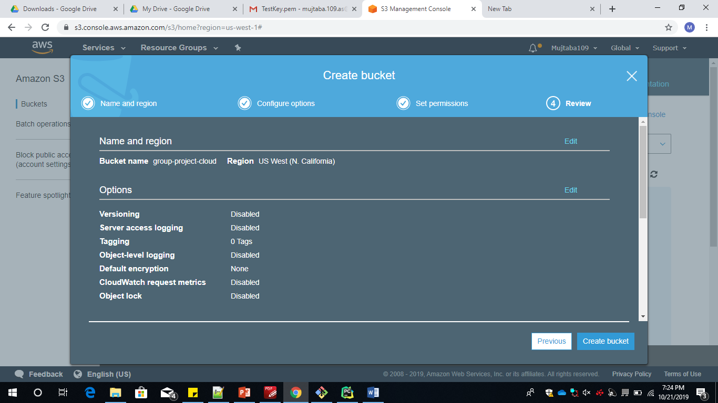

We upload the datset which is in the form of .json file

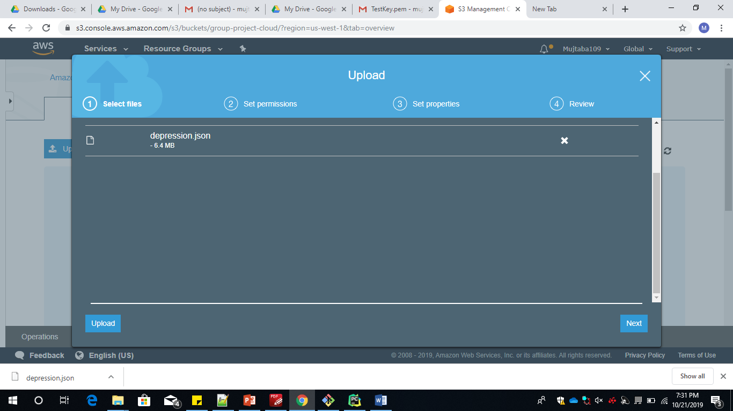

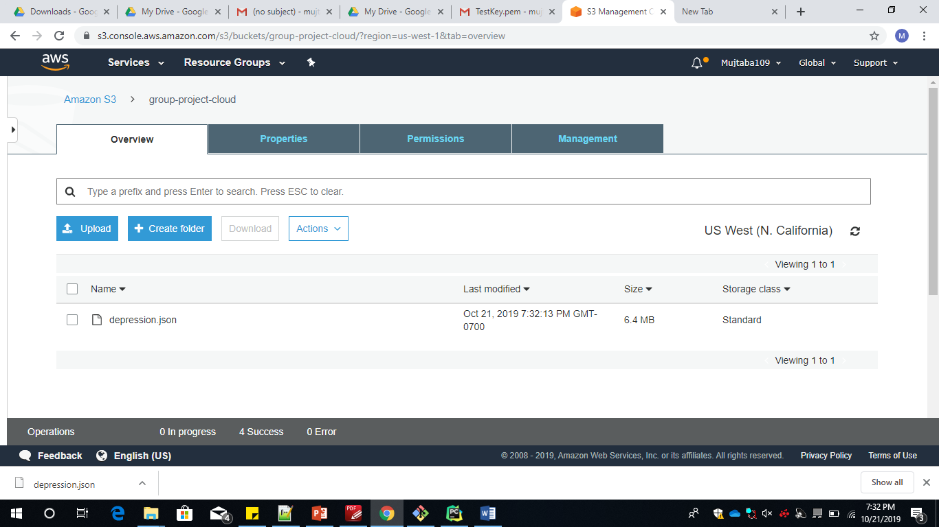

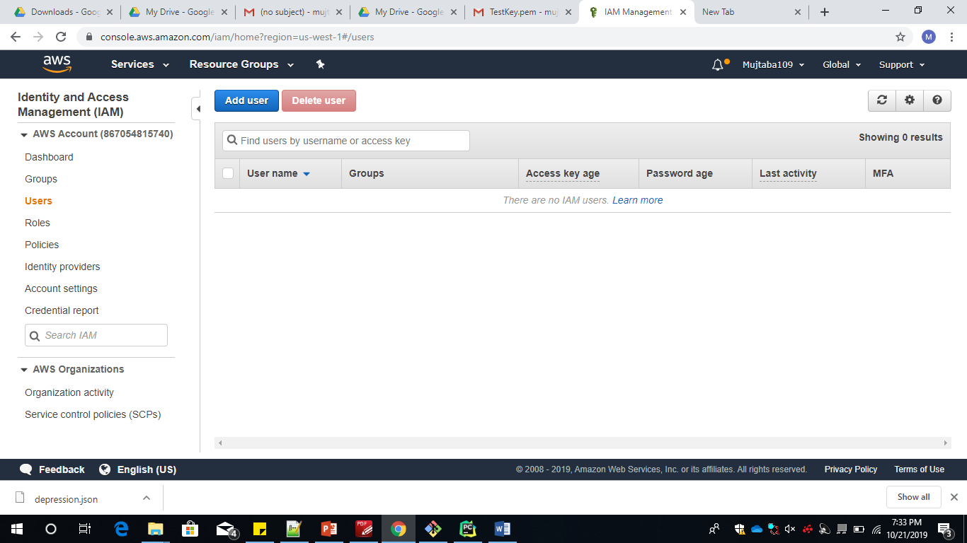

To give access of Amazon webservice to any external user we need to create a IAM user group on the top right of the tab containing the username we get an option called My security credentials .Here we have to provide a username to the IAM user and check-box Programmatical access which gives us a access ID and secret access key, this can be downloaded as an excel file

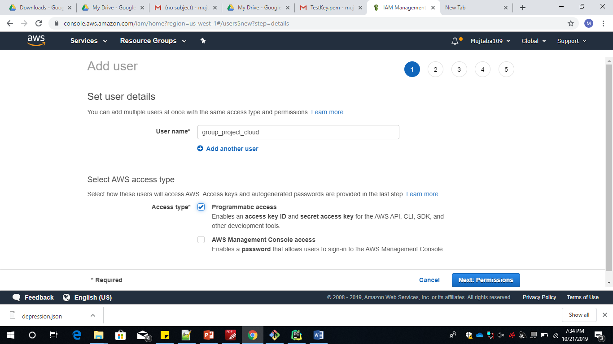

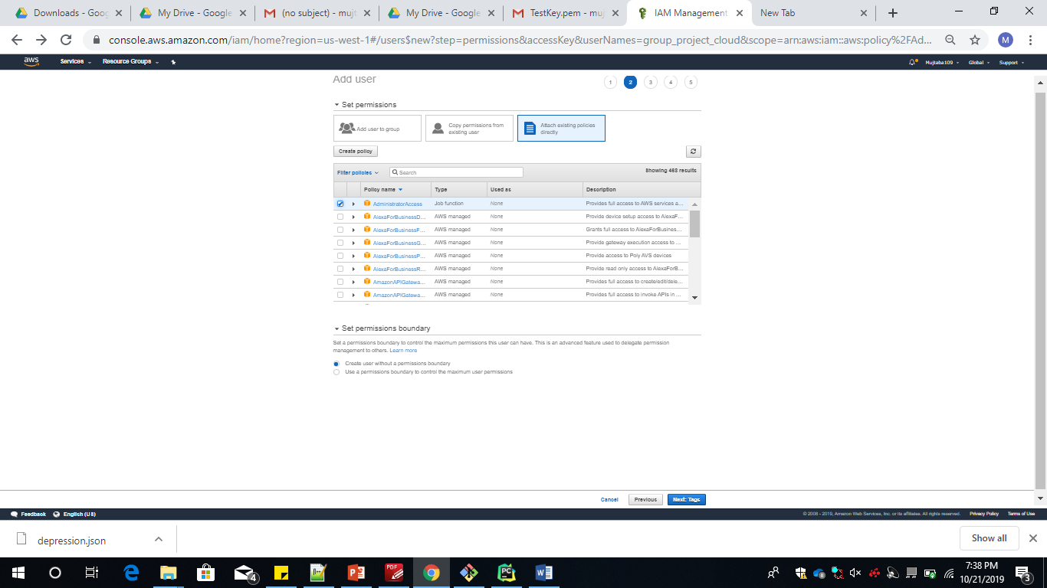

Further after selecting we have to give admin access to all the users who want to access the file.

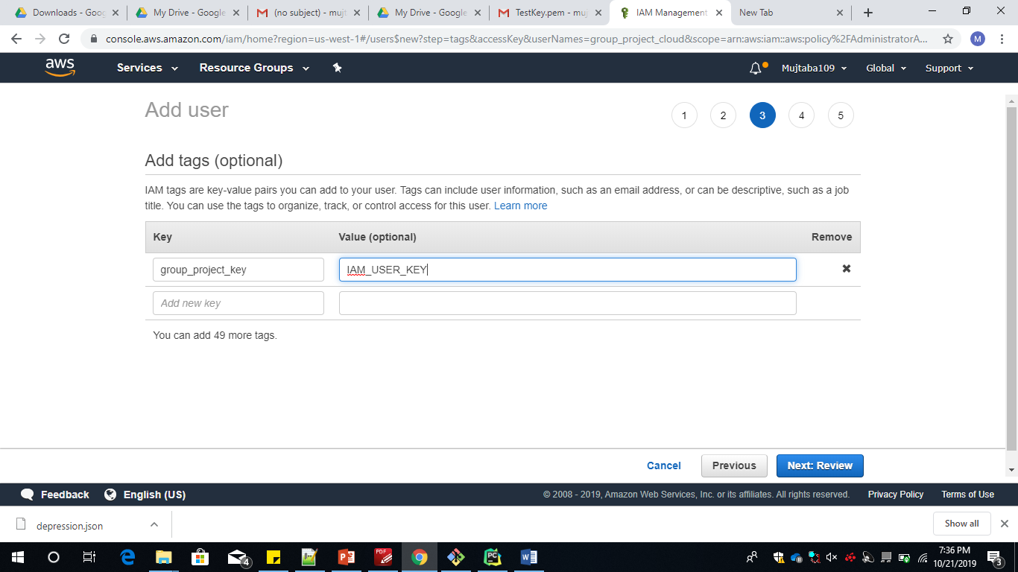

We provide a username to the user who wants to access the services of aws .

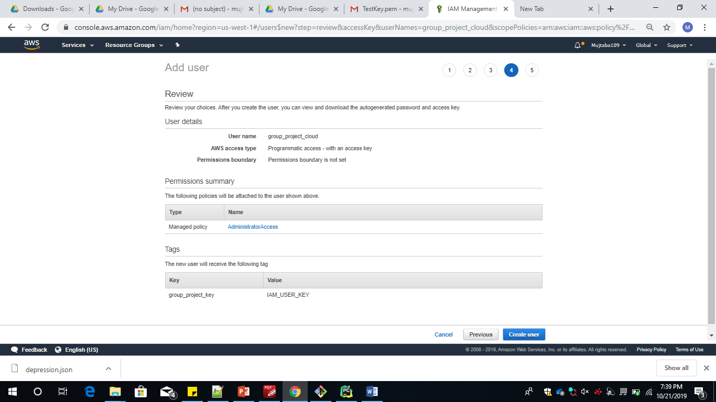

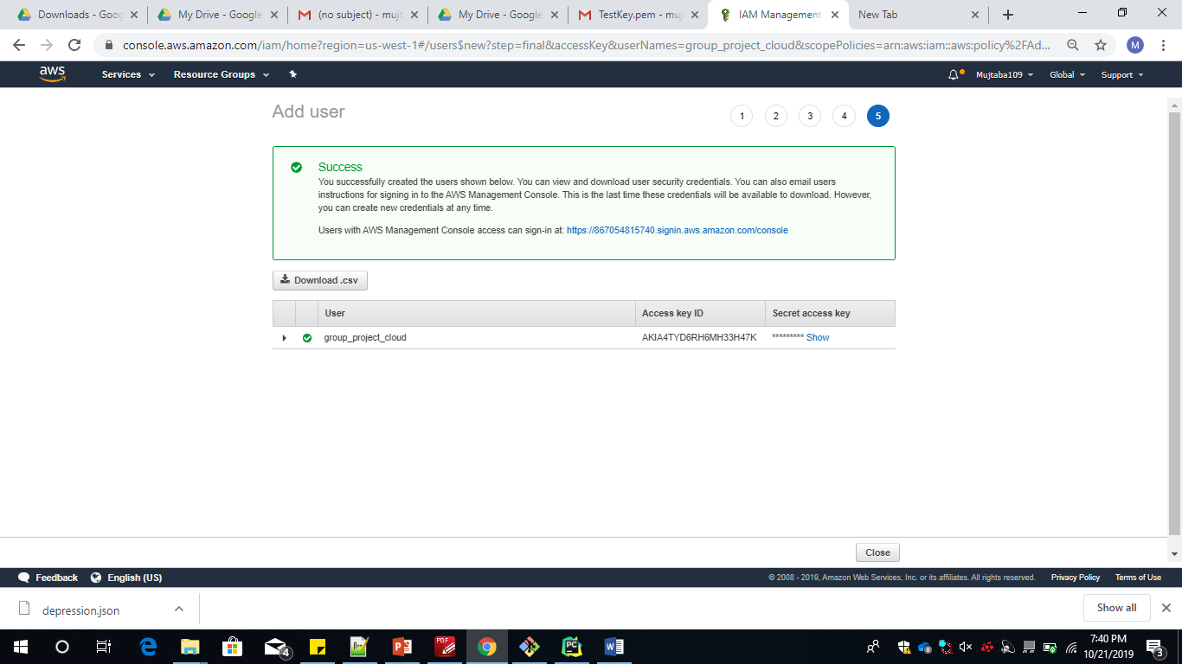

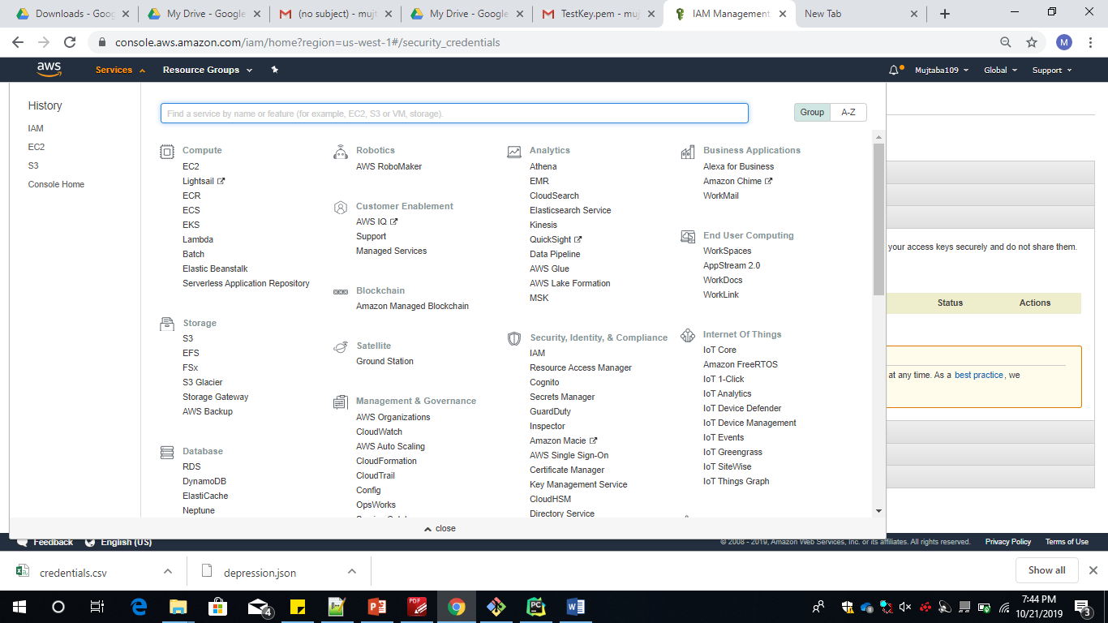

Initially while creating the Cluster Instance .A key would be automatically created for accesing the General services of AWS.

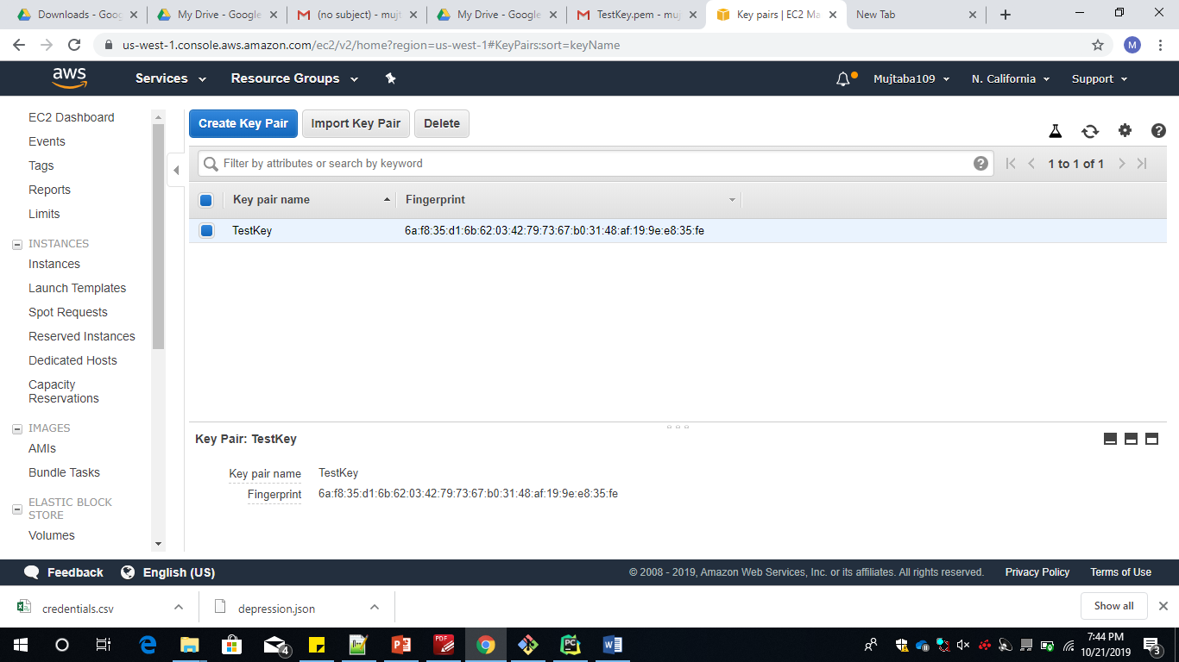

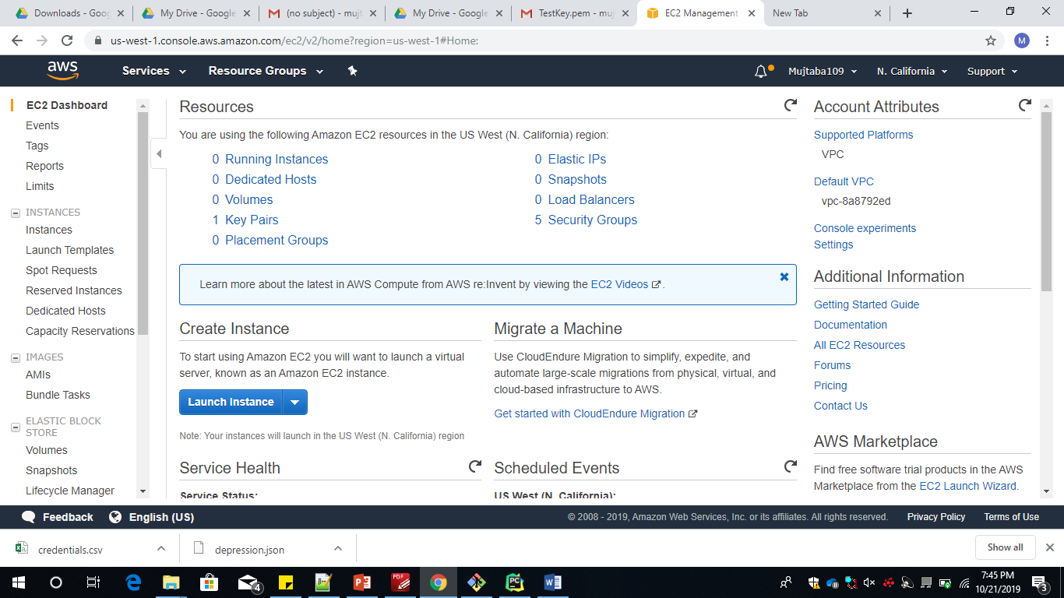

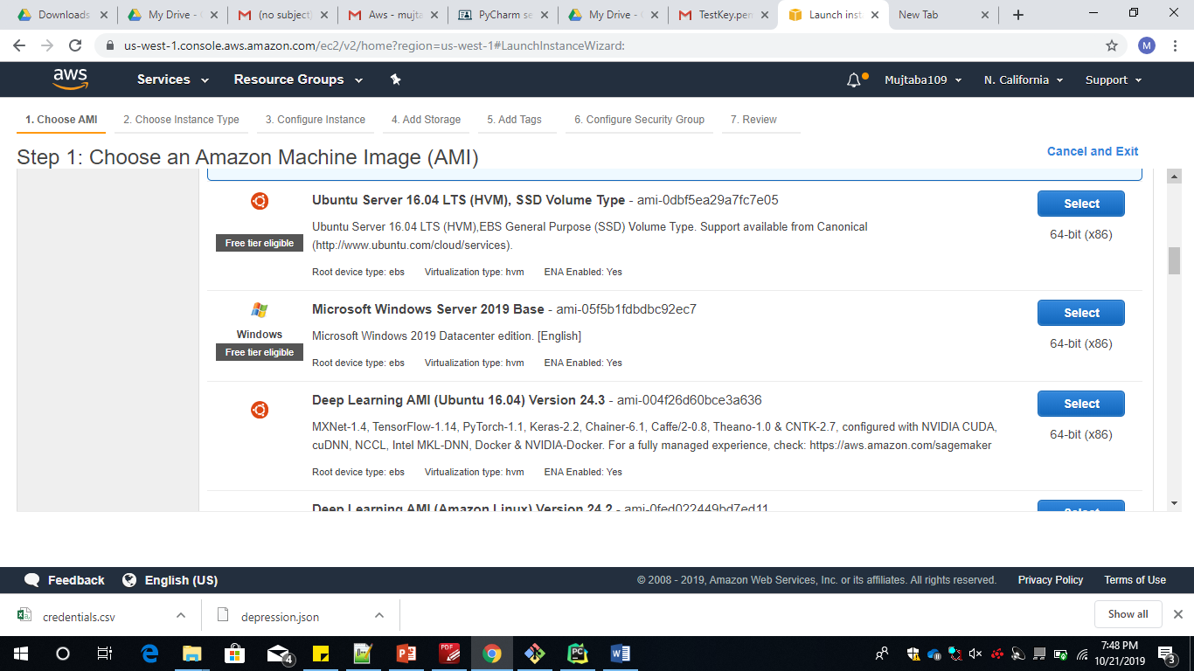

We need to create a Ec2instance for this we have chosen a Ubuntu Server(T2 micro ).Click on create instance and launch the cluster.

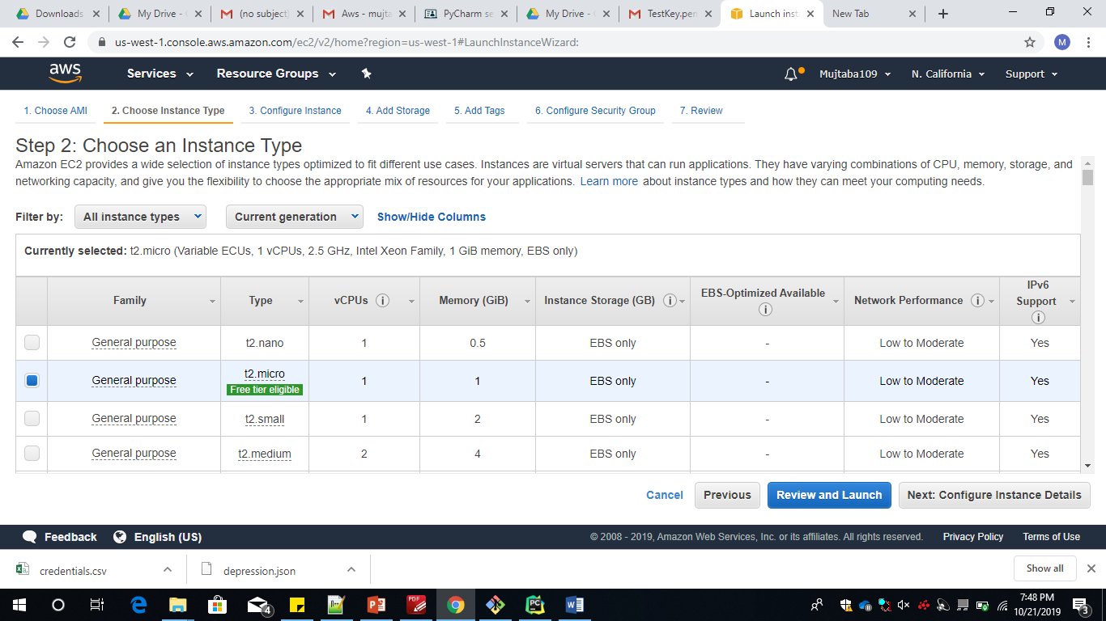

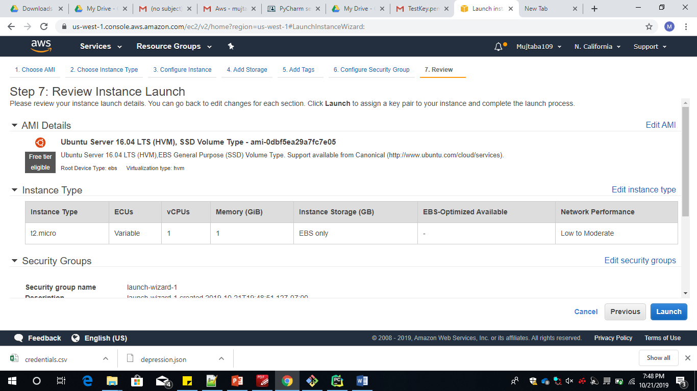

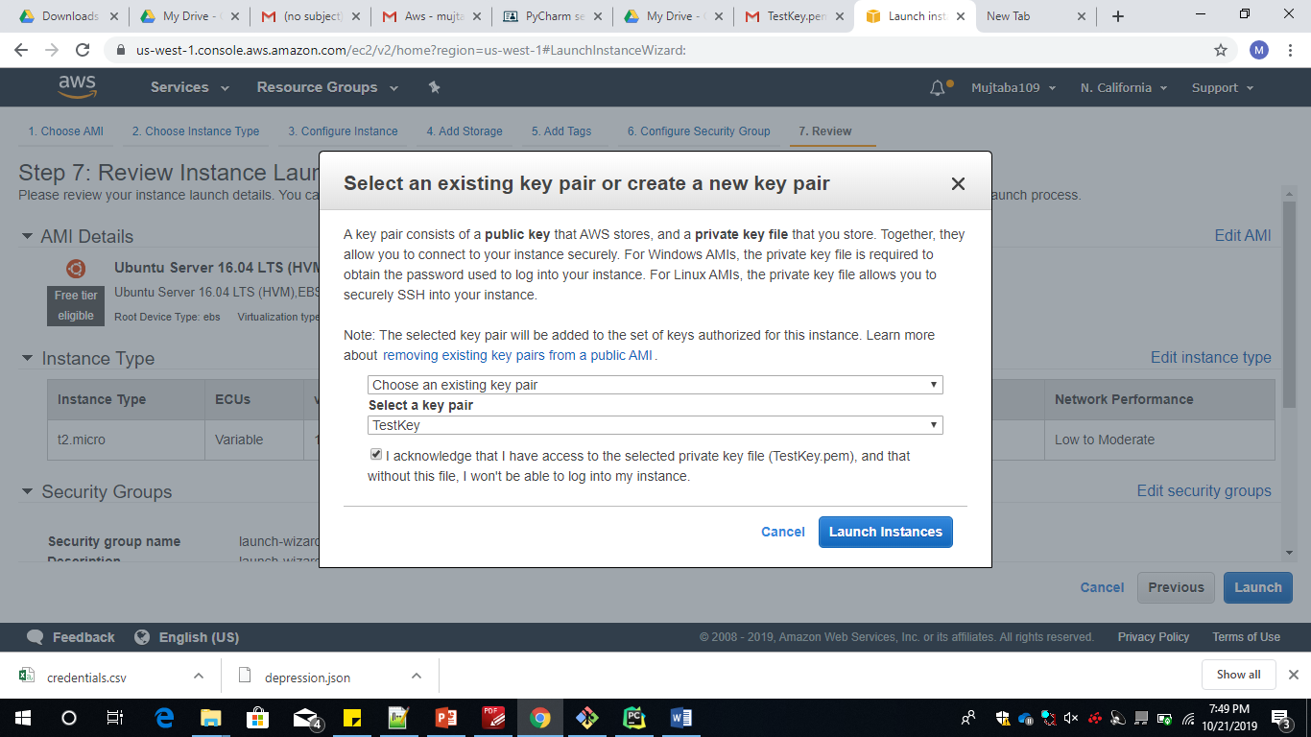

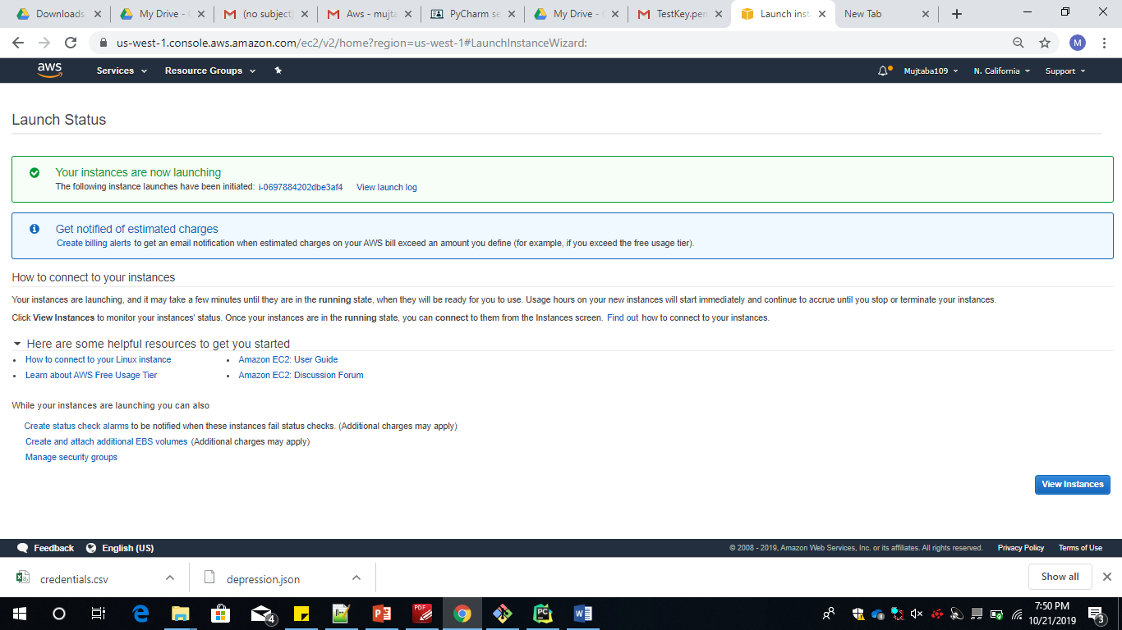

To launch the cluster we have options of providing a key or we could choose the already existent key .

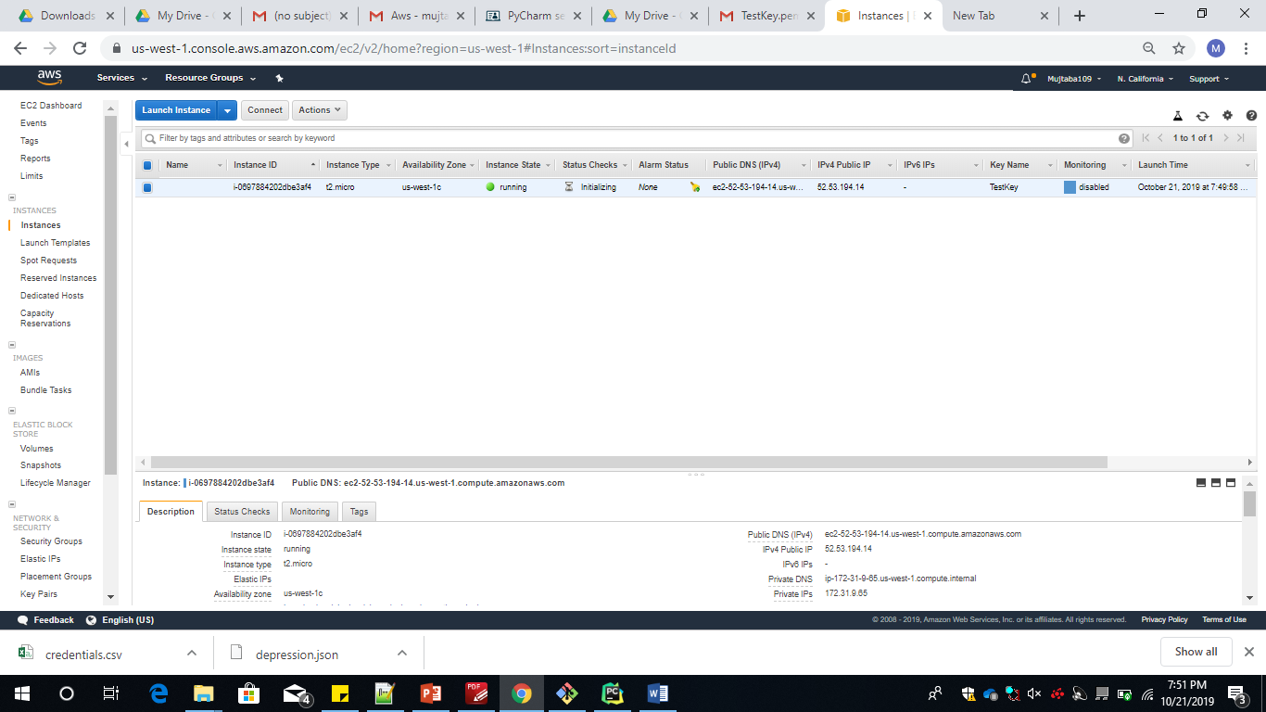

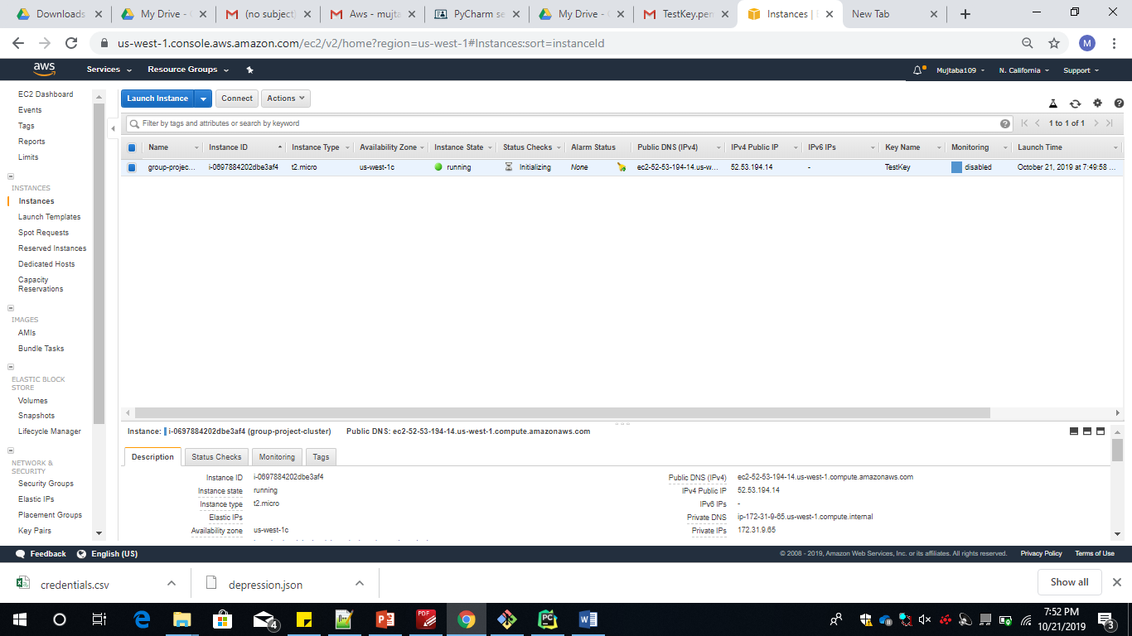

Following the cluster creation we have to give a Name to the key, We can access the ec2 instance publically using the DNS Link provided

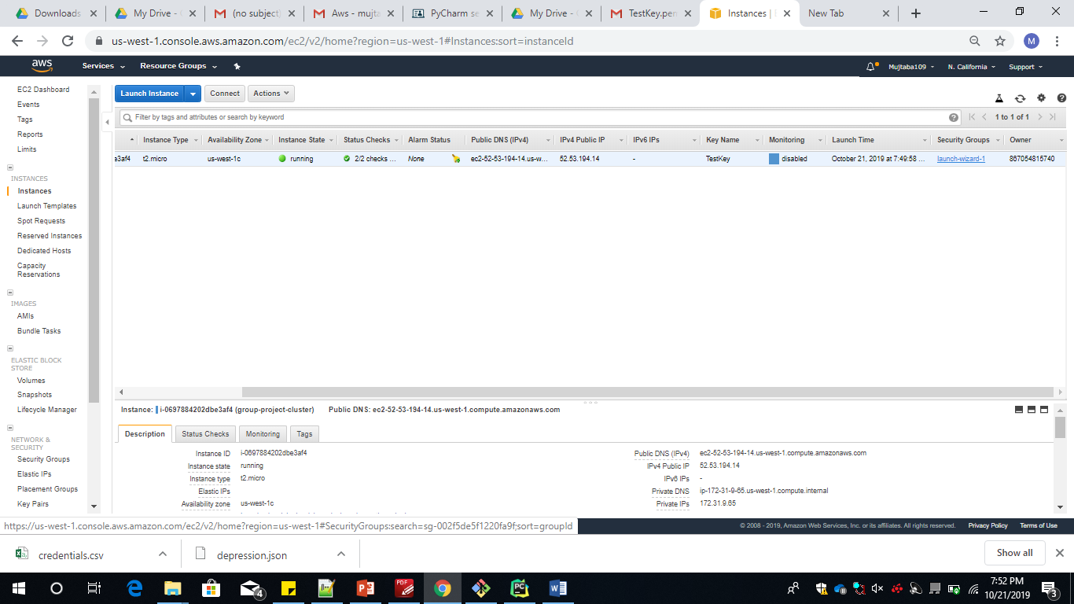

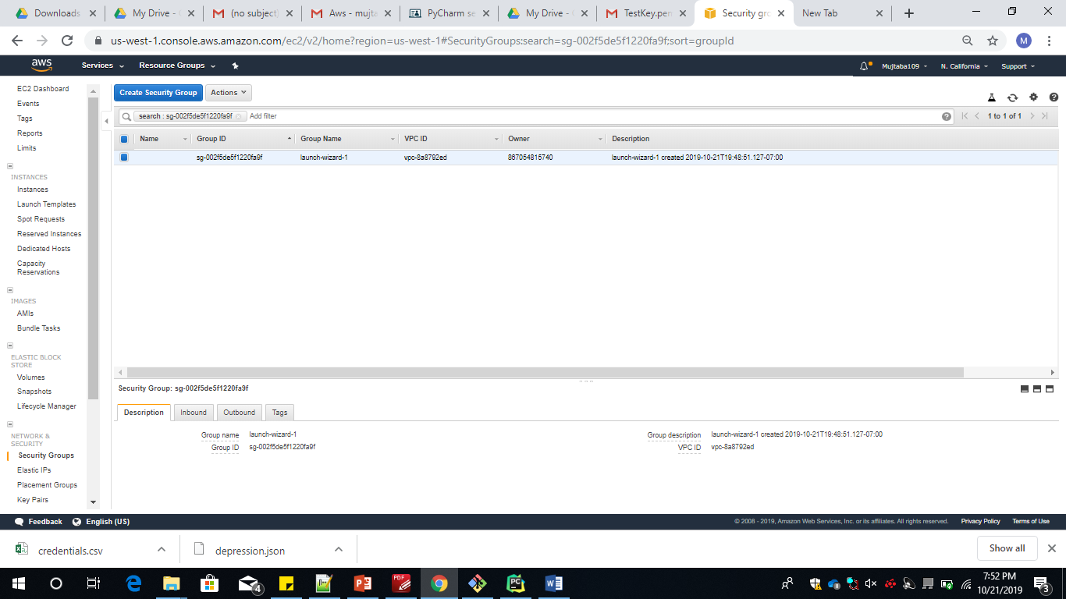

Inorder to use the instance from a remote system we should add a https connection

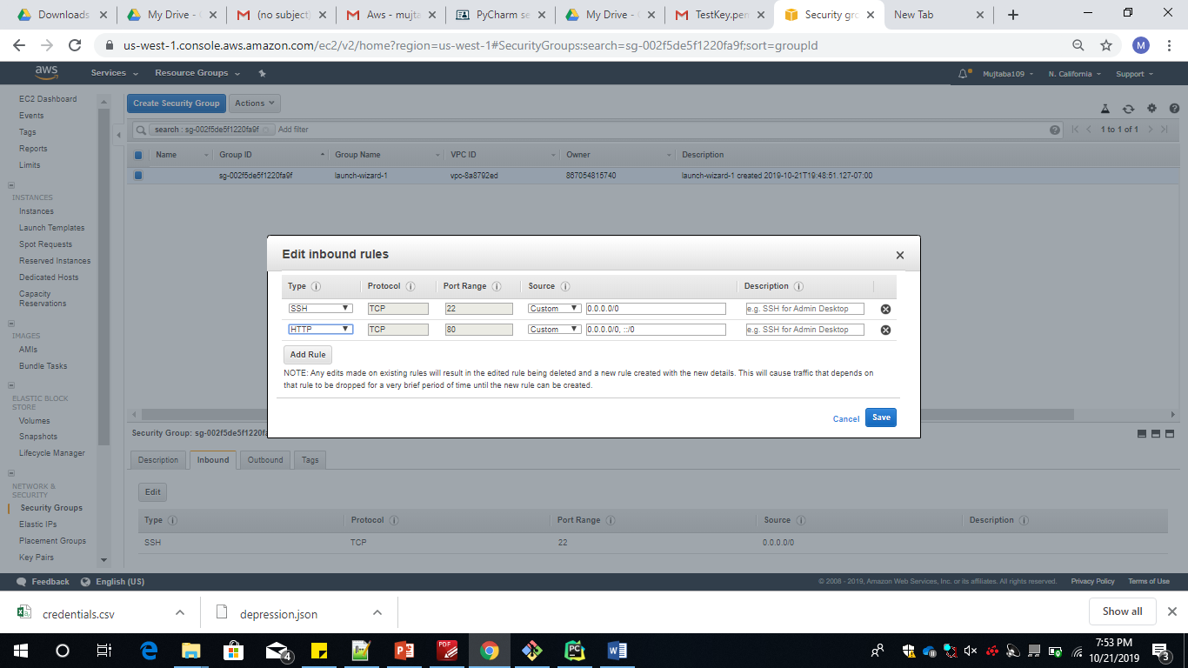

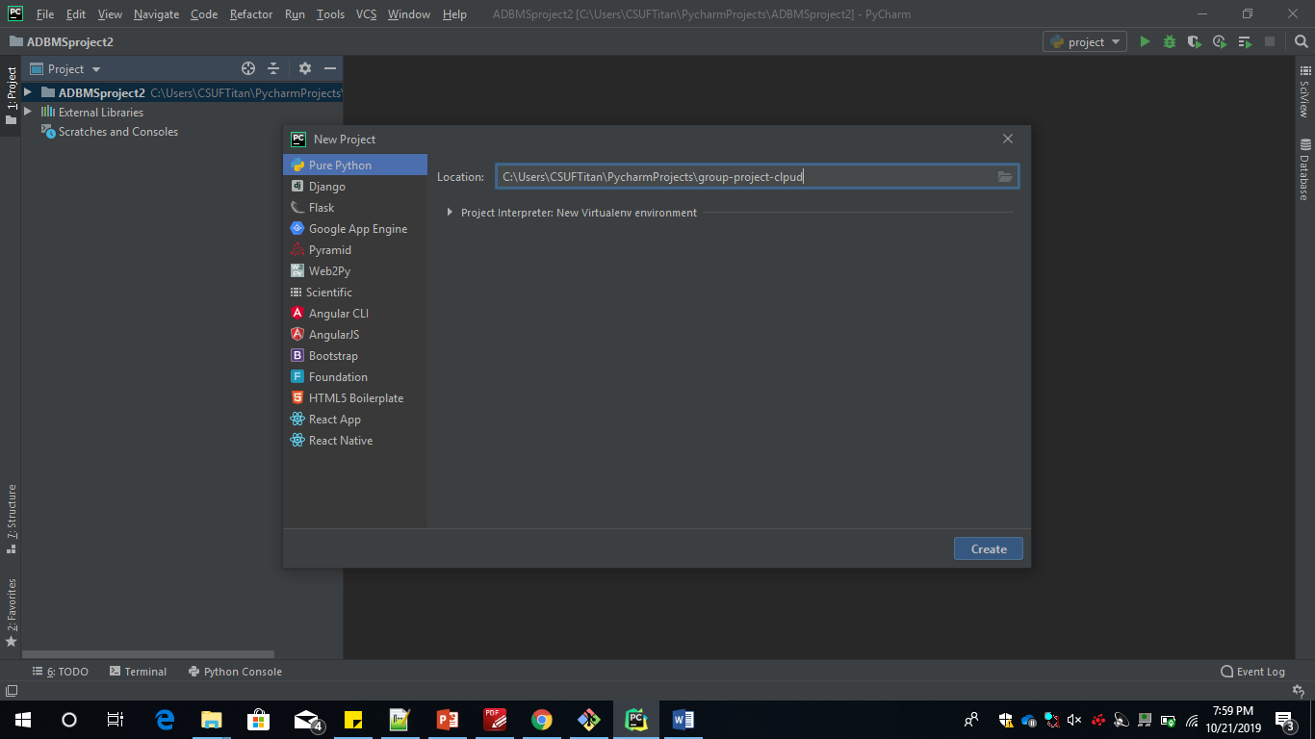

This phase involves creation of the python file in The Pycharm IDE where we will implement the Machine Learning algorithms.

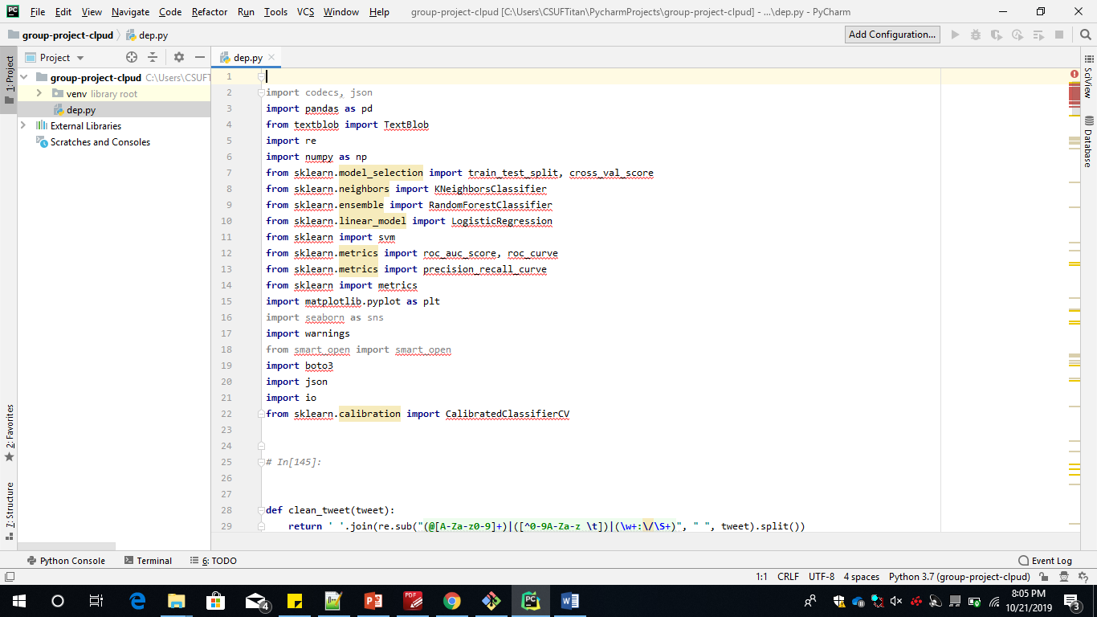

To connect pycharm with the S3 bucket where we fetch the .json file required for processing we need to connect to the project interpretor where we select the SSH Interpretor and provide the DNS of the ec2 instance created and the machine name we have selected.

Then we provide access from the IDE Pycharm to the ec2 instance and other services.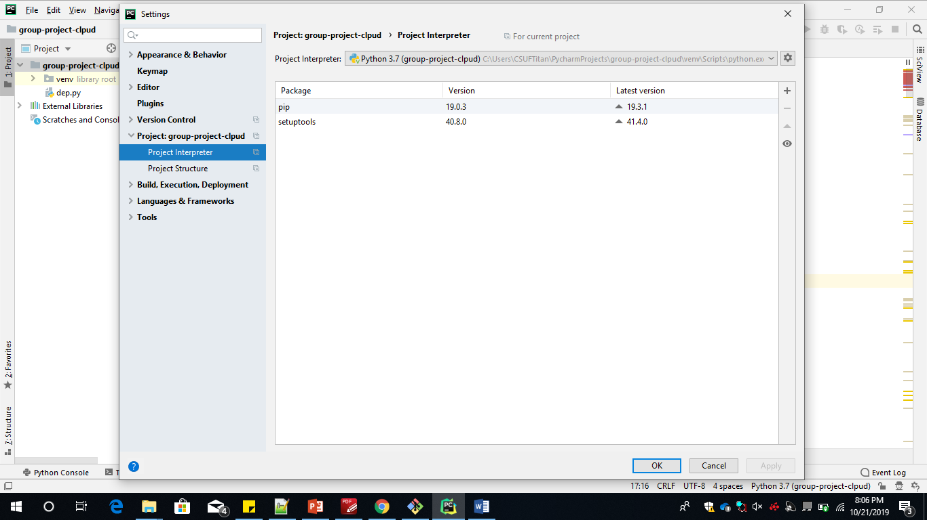

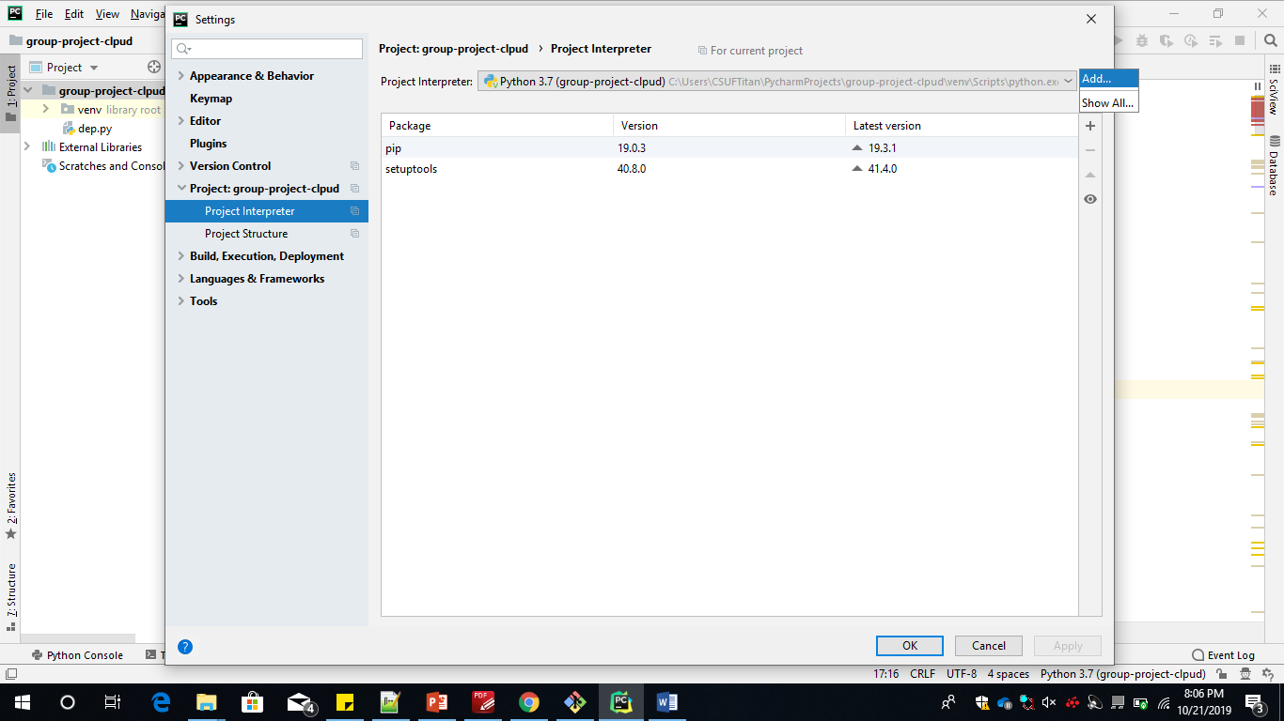

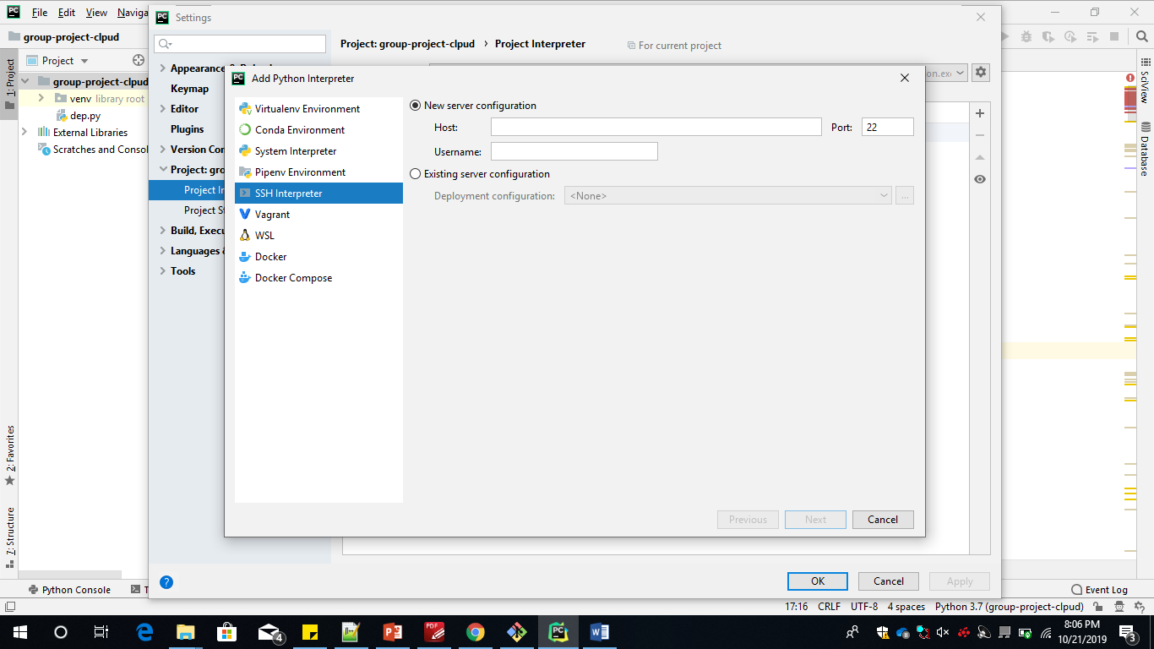

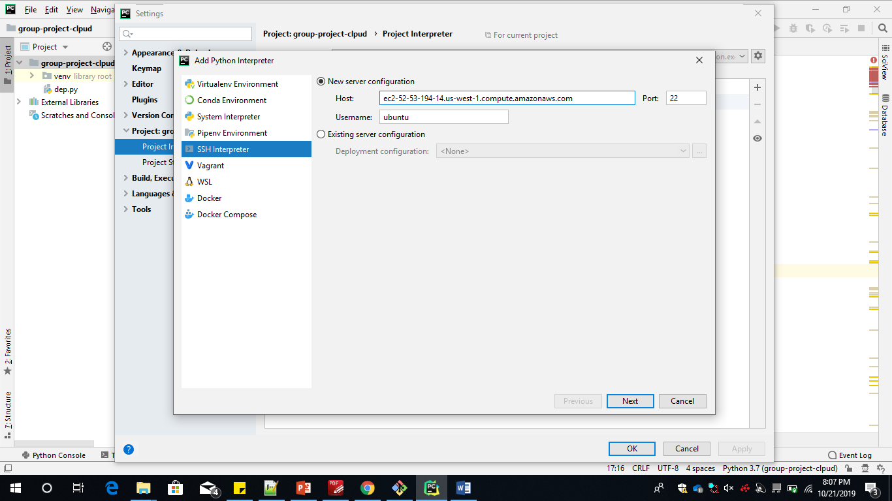

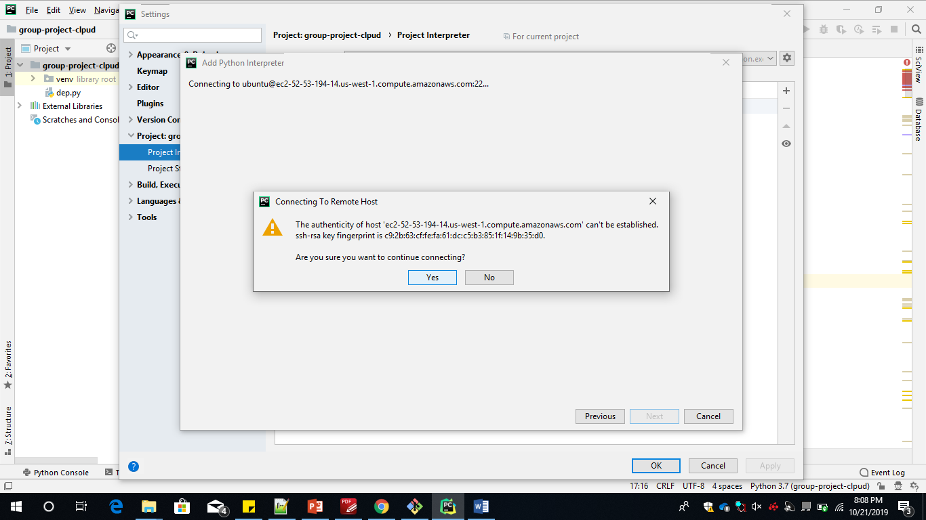

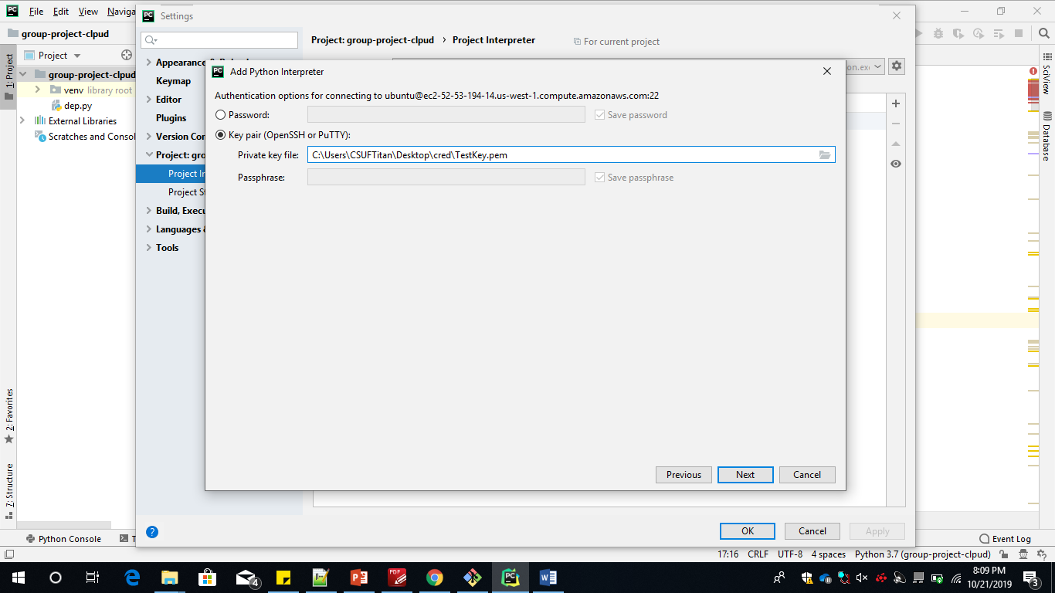

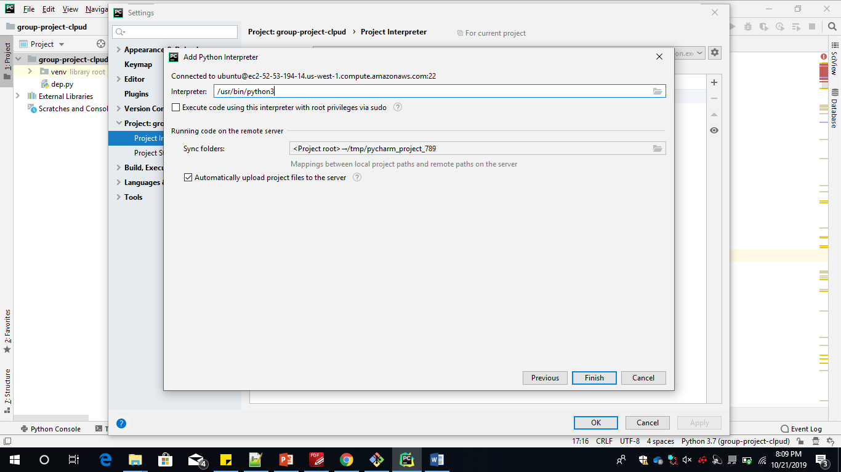

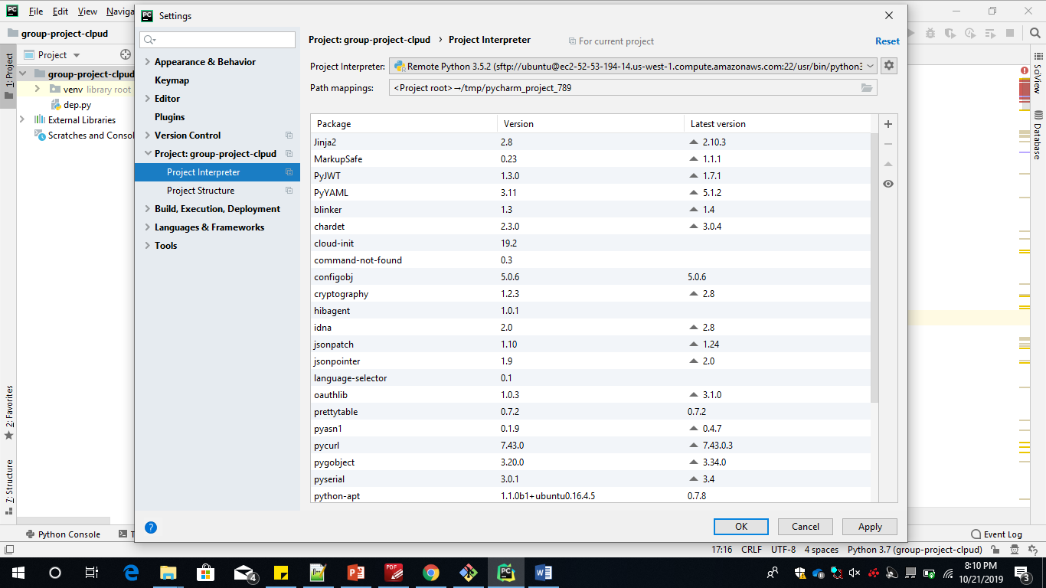

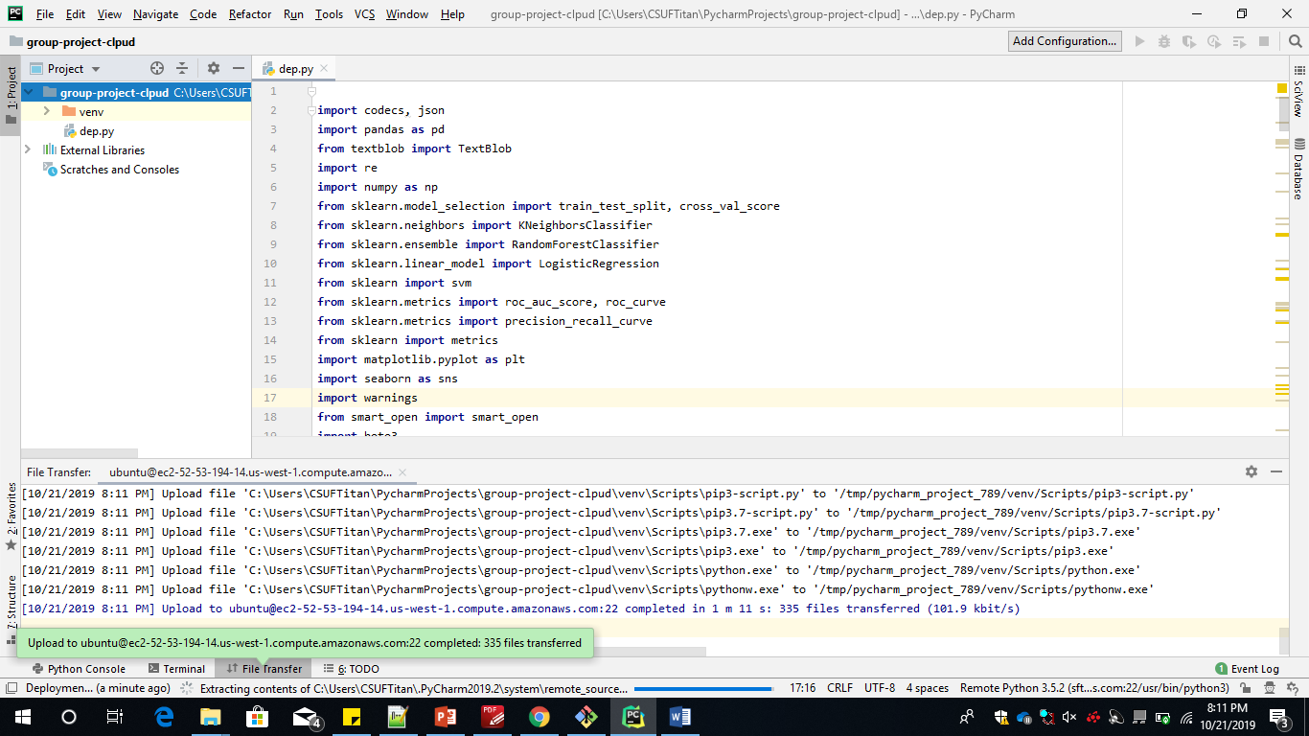

Then we upload the code on theec2 instance.To acces the ec2 instnace we need to connect to the machine remotely using gitbash.

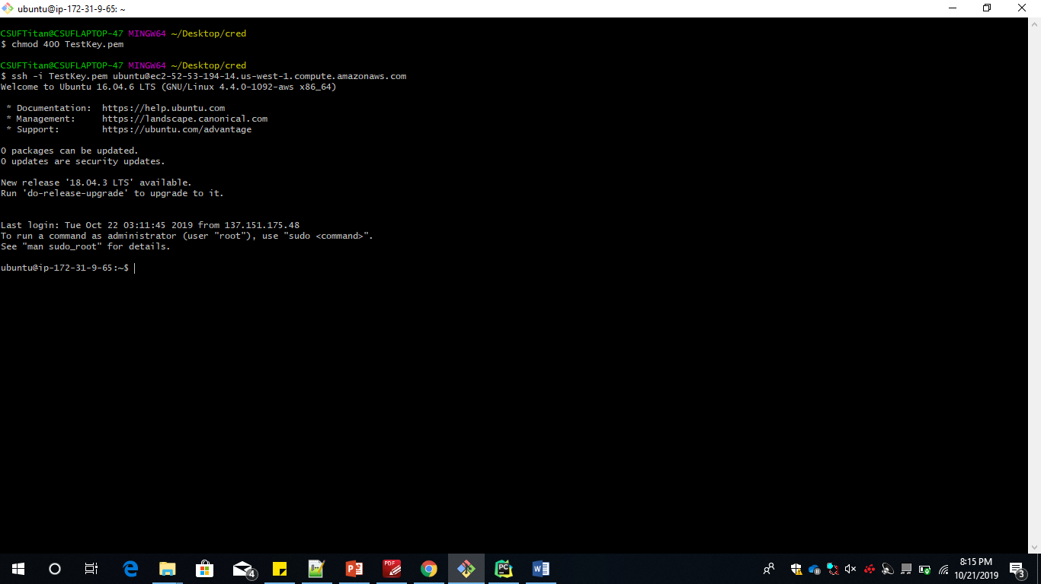

Gitbash is used to connect the ec2 isntance for this we go to the local directory where the key is store and change the permisiion using the command chmod 400 Keyname.pem

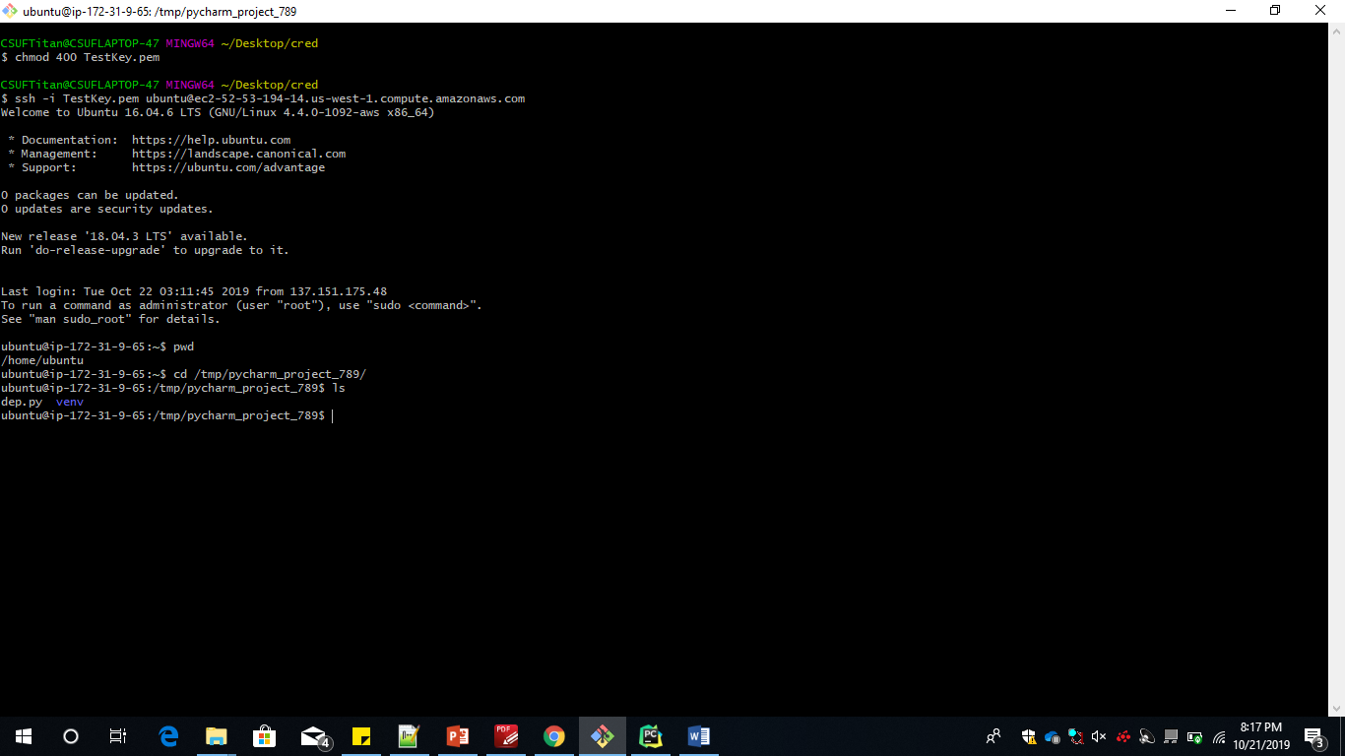

We need to run all the below command to install python dependencies on remote machine

* sudo apt-get udpate
* sudo apt-get install python3-pip
* pip3 install numpy
* pip3 install sklearn
* pip3 install matplotlib
* pip3 install textblob
* pip3 install pandas
* pip3 install boto3
* pip3 install json
* pip3 install xlsxwriter
* sudo apt install awscli

or

pip3 install aws cli

* aws configure

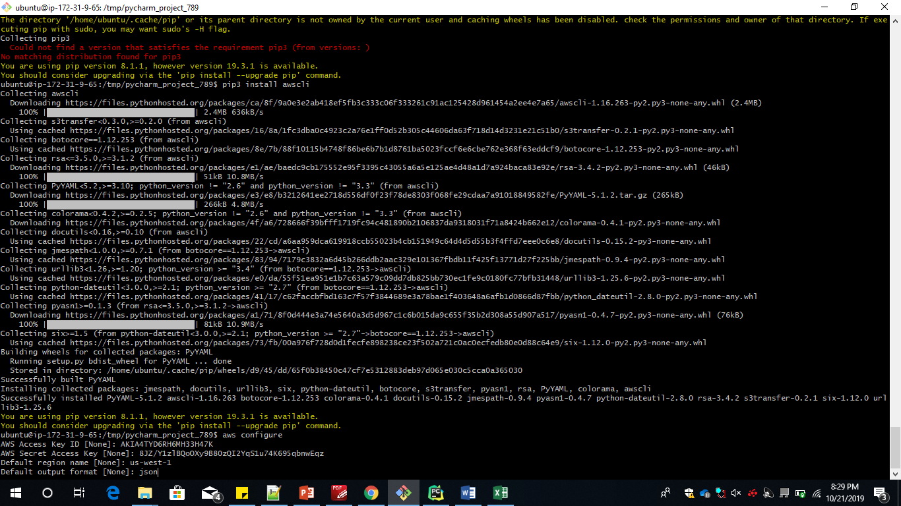

* sudo python3 my_aws_script.py

After installing the python dependencies we run the code on the ec2 instance where we get the respone on the ec2 machine and the result is stored in S3 bucket.

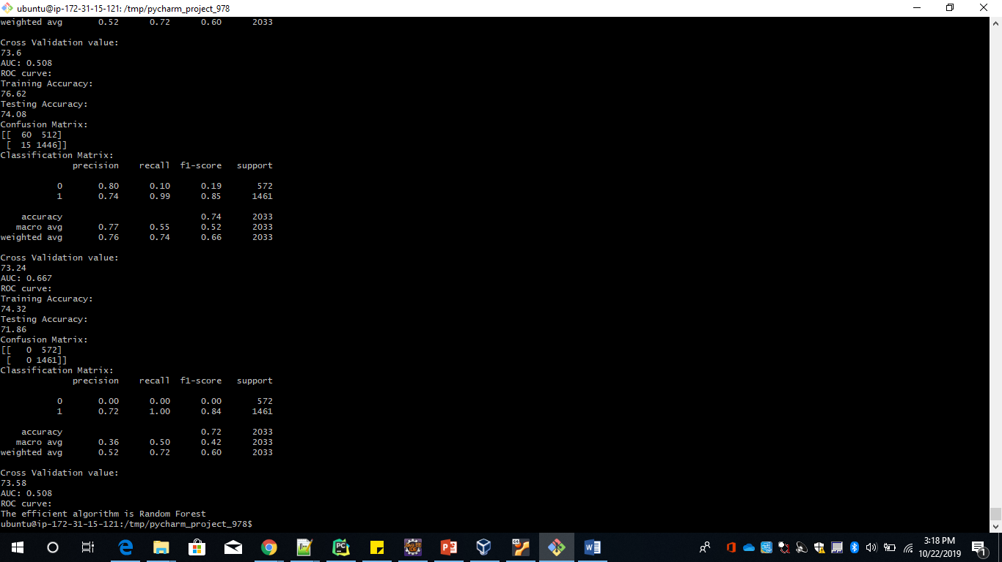

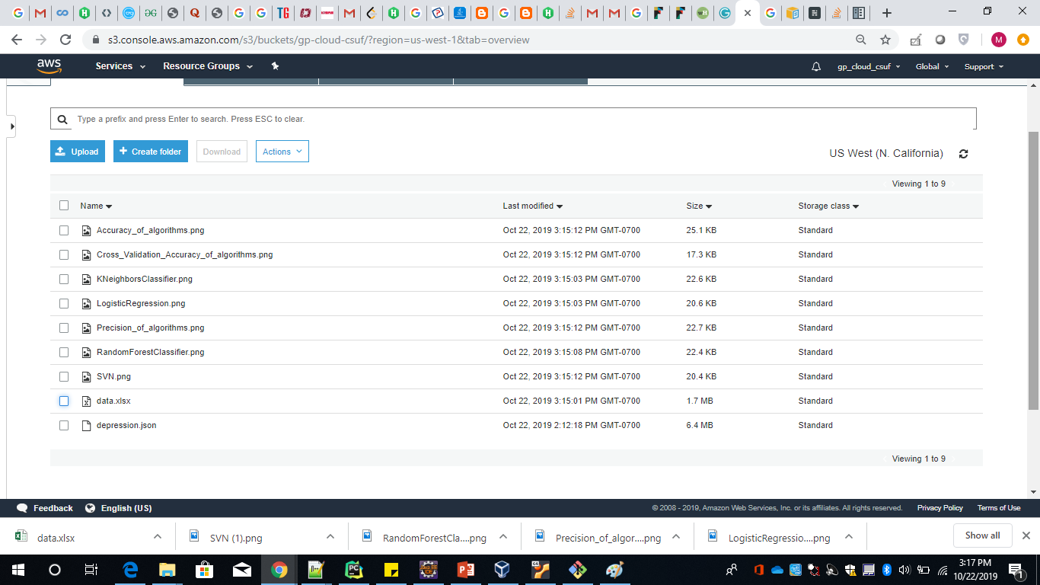

Kneighbour Classification

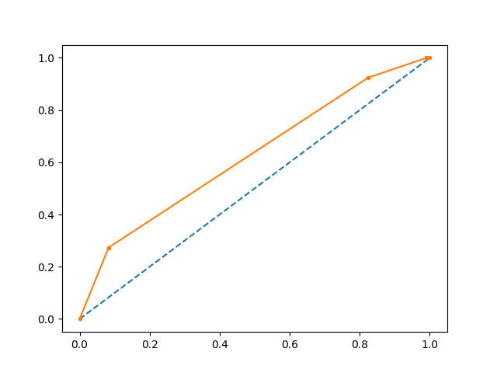

Logical Regression

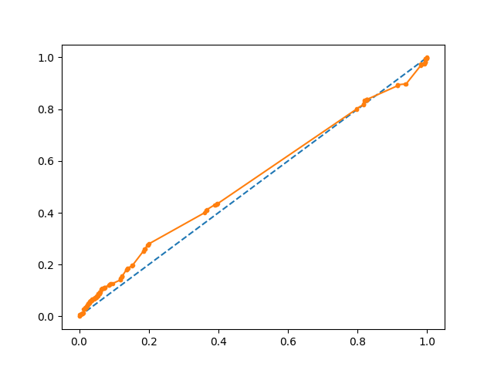

Random Forest Classification

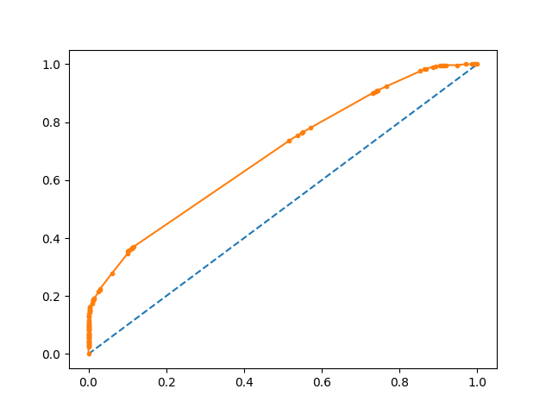

SVM

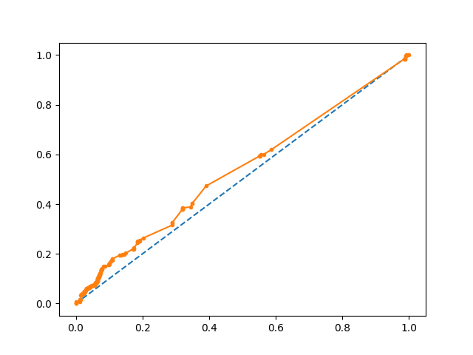

Precision of Algorithm

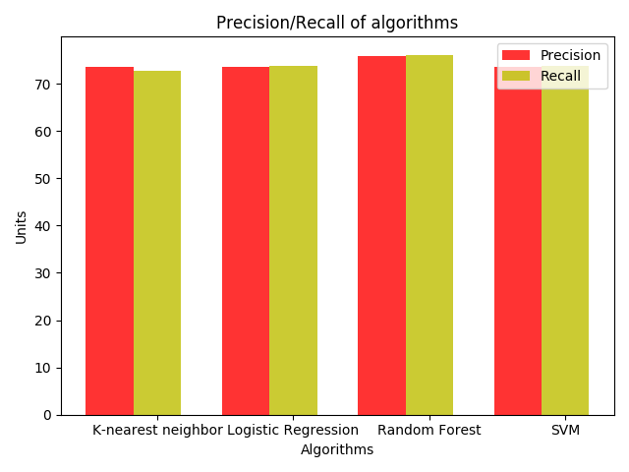

Cross Validation Accuracy of Algorithm

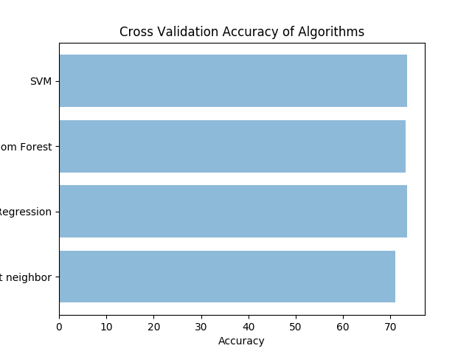

Accuracy of Algorithms

